1. <https://www.anaconda.com/products/individual#Downloads>

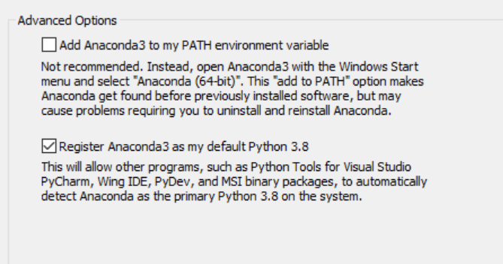

1. <https://code.visualstudio.com/download>

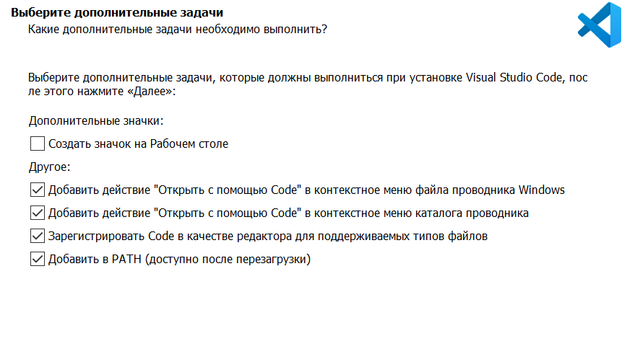

3)Настройка VSC

